Vector databases do vector retrieval by similarity search using a distance metric (where closer means the results are more similar) such as Euclidean, dot product, or cosine similarity.

BERT: The Foundation Model for BGE-M3 and Splade
BGE-M3 and Splade models are built upon the foundational BERT architecture. So, before we dig into their capabilities, we need to understand the underlying mechanics of BERT and how it serves as a cornerstone for advancing embedding technology. Let's dive in.
BERT, or Bidirectional Encoder Representations from Transformers, represents a leap in Natural Language Processing (NLP). Unlike traditional models that process text sequentially, either from left to right or right to left, BERT captures the context of words by examining the entire sequence of words simultaneously rather than in one direction.
The essence of BERT lies in its pre-training process, which is not just a routine but a combination of two innovative strategies:
- Masked Language Modeling (MLM): This task randomly hides a portion of the input tokens and then trains the model to predict these masked tokens. Unlike previous language models that might only understand unidirectional context, BERT fills in the blanks by considering the entire context of the sentence, both the left and right of the masked word.
- Next Sentence Prediction (NSP): In this task, BERT learns to predict whether one sentence logically follows another, which is crucial for understanding relationships between sentences, such as those found in paragraph structures.

LLM Workshops
https://github.com/mlabonne/llm-course

Vector Embeddings
- Sparse Embeddings
- Dense Embeddings - BERT
- Learned Sparse embeddings

https://medium.com/@ahmed.mohiuddin.architecture/using-ai-to-chat-with-your-documents-leveraging-langchain-faiss-and-openai-3281acfcc4e9

Embedding Models Ranking
https://www.llamaindex.ai/blog/boosting-rag-picking-the-best-embedding-reranker-models-42d079022e83

Tech Stacks

- the “analytical” tech stack
Snowflake, dbt, Airflow, Iceberg, Tableau
- the “low latency” tech stack
Kafka, Flink/Spark Streaming, Iceberg, Redis, Apache Pinot
- the “big data” tech stack
Databricks, Spark, Delta Lake/Iceberg, Apache Superset
- the “LLM” tech stack
Neo4j, Pinecone, Claude/ChatGPT, Predibase
- the “Azure” tech stack
Microsoft Fabric, Azure Data factory, Azure Synapse, PowerBI

Frameworks

RAG Frameworks – LlamaIndex, LangChain, TxtAI
Embeddings – BG-E, Splade, OpenAI Embeddings, HuggingFace Embeddings
Vector DB – Chroma DB, Pinecone, FAISS, Neon DB- pgVector, Milvus

Milvus - https://github.com/milvus-io/bootcamp/tree/master
Chat Models - https://python.langchain.com/docs/integrations/chat/

Few Keywords in LLM
- Embedding Models
  - https://www.bentoml.com/blog/a-guide-to-open-source-embedding-models
- BERT – Bidirectional Encoder Representation from Transformers
- MTEB – Massive Text Embedding Benchmark
- RAG Metrics
  - Hit Rate
  - Mean Reciprocal Rank
- RAG or FineTuning
  - Both have their pros and cons

Building a small RAG App Version 1

https://dev.to/rogiia/how-to-build-a-basic-rag-app-h9p

LlangChain -> PYPDF Parser->PDF Document Chunking
BGE-Small from HuggingFace Hub->Embeddings
FAISS Vector Database->Claude Haiku as LLM

Building a small RAG App Version 2

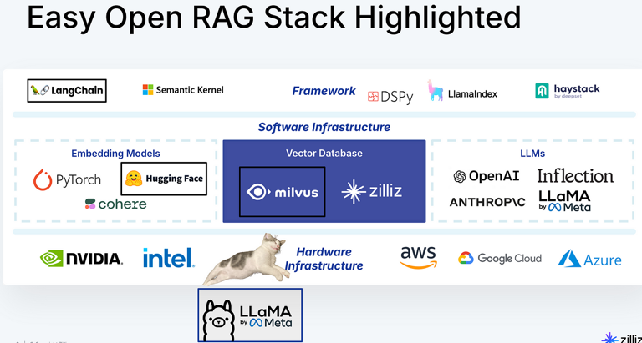

ollama==0.3.3 # Local inference
chromadb==0.5.20 # Vector Database
Did not work. It required SQLite3 > 0.35.

Trying Milvus now – Index below
Diverse Index Support. It supports over 10 index types, including HNSW, IVF, Product Quantization, and GPU-based indexing. This variety allows developers to optimize searches for specific performance and accuracy requirements. Examples of these organization methods include flat structures, inverted file (IVF), Hierarchical Navigable Small Worlds (HNSW), and locality-sensitive hashing (LSH),

sentence-transformers==3.3.1 # CrossEncoder Re-ranking
streamlit==1.40.1 # Application UI
PyMuPDF==1.24.14 # PDF Document loader
langchain-community==0.3.7 # Utils for text splitting

Installing Ollama on Github Codespaces – Linux Machine
curl -fsSL https://ollama.com/install.sh | sh

Issues faced until now
- ChromaDB required higher SQLite which I was not able to install. So settled for Milvus. Challenges in getting Milvus work
- Ollama was occupying more space. And it was eating the root folder in Github workspaces. Was looking for environment variable to update the location where Ollama pulls models. Did not work out
- Space was a major constraint.
- So trying it in local machine
- Activated CONDA environment
- PIP install Streamlit did not recognize the environment. So did a Conda install
- Conda was a pain as it could not see the langchain and other things
- So created a virtual environment with python venv
- Changing Models path of Ollama https://dev.to/hamed0406/how-to-change-place-of-saving-models-on-ollama-4ko8
- Issues of installing Sentence transformers on 3.13. So had to downgrade Python to 3.9
- TOKENIZERS_PARALLELISM=false – Hugging face transformers

Enriching the LLM with RAG

https://www.mongodb.com/developer/products/atlas/rag-atlas-vector-search-langchain-openai/
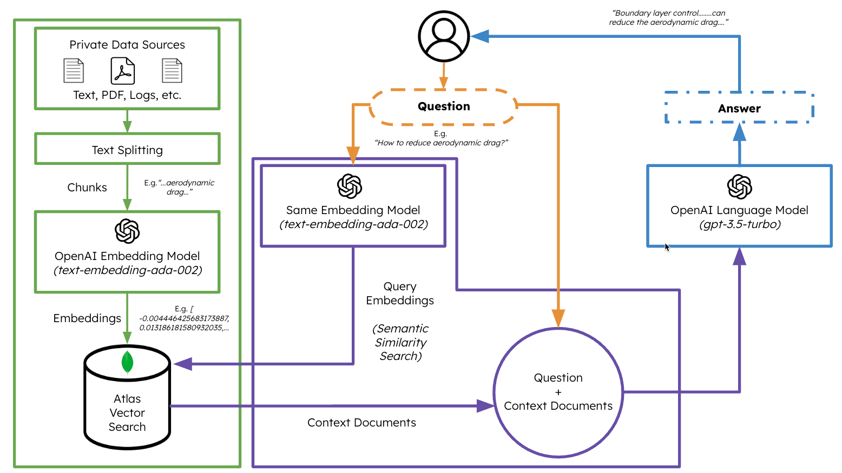

https://python.langchain.com/docs/integrations/retrievers/self_query/pinecone/
https://docs.llamaindex.ai/en/stable/examples/vector_stores/PineconeIndexDemo/

context = "\n".join([matches['metadata']['text'] for matches in context_documents])
# Prepare the prompt
prompt = f"Answer the following question based on the provided context:\n\n{context}\n\nQuestion: {query}\nAnswer:"

# Request response from OpenAI LLM
response = openai.Completion.create(
model="gpt-4o-mini", # Or any other available OpenAI LLM models
prompt=prompt,
max_tokens=200,
temperature=0.7
)
#return response['choices'][0]['text'].strip()
return response

